|  |
| --- |
| Version 2.1 January 2020 |
| China CITIC Bank  London Branch  Credit Approval and Credit Risk Management Policy |
|  |



**Document History**

|  |  |  |  |
| --- | --- | --- | --- |
| Owner | Chief Risk Officer | Status | Draft |
| Version | 2.1 | Date | January 2020 |
| Approved by | Management Committee | | |
| Approved Date |  | Next Review Date | January 2021 |
| Location | London | | |

|  |  |  |  |  |
| --- | --- | --- | --- | --- |
| **Version** | **Owner** | **Approval** | **Date** | **Major changes** |
| 1.0 | President | President | May 2018 | PRA Regulatory Business Plan |
| 1.1 | CRO | MANCO | Oct 2018 | As per approval 24/10/2018 |
| 2.1 | CRO | MANCO |  | * Lending Activities (Added Other countries pg 11) * Country Risk (HO allocation of limits pg 15) * Country Risk (added other sources credit pg 16) * Industry Risk (negative impact on industries not targeted or environment/Climate Change pg 18) * Credit Principles(CCo approval is specific pg 18) * Legal, (waivers / amendments approval pg 19) * External Credit ratings (HO internal credit will be used for DOA, RAROC, ECL pg 20) * Internal credit model (updated to reflect HO methodology/terminology pg 20) * New credit facility process (added introduction of Credit Application Log pg 21) * Credit Classifications (New pg 21) * Credit monitoring (clarified daily monitoring with weekly/monthly reporting pg 21) * Appendix A – DOA (updated for Jan 2020 pg 30) * Appendix B – Risk Appetite (update as per MANCo approved RAS pg 31) * Appendix H – Credit Classification (new pg 49) * Appendix I –Credit Rating Methodology (deleted Industry type models pg 48) * Appendix J – RWA (new pg 53) * Appendix K – RAROC (new pg 54) |

Content

1 Introduction 5

2 Objectives 5

3 Policy Ownership/Oversight 6

4 Risk Management Framework 7

5 Roles and Responsibilities 8

Three Lines of Defence 8

Risk Governance 9

6 Credit Strategy 11

Lending Activities (Target Market & Products) 11

Credit Risk definition 12

Concentration Risk 14

Large Exposure Limits overview 14

Credit Risk Mitigation 14

7 Country Risk 15

8 Industry/Sector Risk 18

9 Credit Approval Process 18

Credit Principles 18

Credit application documentation 19

Legal documentation 19

External Credit Rating 20

Internal Credit Rating 20

New Credit Facility Approval Process 21

Credit classification 21

Credit Monitoring and Review Process 22

10 Credit Impairment/Expected Credit Loss 25

Asset Classification 25

Stage 1 Exposures 26

Stage 2 Exposures 27

Stage 3 Exposures 28

Monitoring of Stage 3 Exposures 28

11 Record Keeping 29

12 Training 29

13 Appendix A - Credit Risk Delegated Authority 30

14 Appendix B – Risk Appetite 31

15 Appendix C – Credit request format Corporate 33

16 Appendix D – Credit request format Financial Institutions 37

17 Appendix E – Corporate Credit Approval Process 40

18 Appendix F – Sovereign/Corporate Bond Credit Approval Process 42

19 Appendix G –Financial Institutions Credit Approval Process 45

20 Appendix H – Credit Classification 48

21 Appendix I – Credit Rating Methodology 50

22 Appendix J – Risk Weighted Asset (RWA) calculation 53

23 Appendix K – Risk Adjusted Return on Capital (RAROC) calculation 54

24 Appendix L – HO IFRS9 calculation methodology 55

# Introduction

This document sets out the approach adopted by China CITIC Bank London Branch (“CNCBLB” and / or “the Branch”) for credit approval and credit risk management.

This policy applies across all relevant products and counterparty types. Where this policy imposes more stringent requirements than other policies, including any applicable at Head Office (“HO”), the requirements of this policy will take precedent.

# Objectives

The objectives of this framework document are to:

* Document, at a high level, how CNCBLB extends credit and manages Credit Risk;
* Assign ownership and accountability for the maintenance of the Credit Policy document; and
* Support the implementation of CNCBLB’s Risk Appetite as it applies to Credit Risk.

It is the responsibility of the Risk department to identify, manage and monitor inherent and emerging Credit Risks and to ensure the implementation and maintenance of prudent credit risk standards.

# Policy Ownership/Oversight

The ’chain’ of ownership and oversight of this policy is set out below:

|  |  |
| --- | --- |
| **Document Owner** | The Branch’s Chief Risk Officer (“CRO”) is responsible for the maintenance for this policy.  The CRO will also be responsible for reviewing the ongoing adequacy of the policy and will review it on an annual basis. Any material changes to this policy must be formally signed off by the Management Committee (“ManCo”) before these changes are communicated to staff. |
| **Challenge** | The Audit and Risk Committee (“ARCo”) will review and challenge this policy at least annually or more frequently as necessary. A recommendation for approval or otherwise must be made to the ManCo following each review.  Reviews outside the annual cycle could be prompted by changes made to the President’s delegation of authority (“DOA”) from HO; or changing regulatory requirements. |
| **Approval** | ManCo reviews and challenges the policy based on the recommendation of ARCo. Not until it has been formally approved by ManCo will proposed changes take effect. |
| **Applicability** | All members of staff, whether permanent (local hires and/or expatriate) or contractors must operate in accordance with this policy. Escalation of any matters arising in respect of this should be via the individual’s Head of Department or directly to the CRO.  To ensure compliance with the requirements of this policy the Risk Department and well as Internal Audit will conduct periodic reviews to ascertain compliance with the provisions of this policy. |

# Risk Management Framework

CNCBLB considers the cornerstone of credit risk management to be a robust overarching risk management framework (“RMF”), supported by clear policies and procedures. This ensures compliance with both general regulatory requirements, HO risk policies and with the Risk Appetite set by the ManCo. Credit Risk management forms and integral part of the overall risk framework, which is presented as follows:



# Roles and Responsibilities

## Three Lines of Defence

In order to manage the credit risk profile of the Branch, a three lines of defence model has been implemented.

### First Line of Defence

First line of defence functions are those that manage and own risks within the Branch; this includes Business Development, Financial Markets and direct support functions (Operations, Finance, Human Resources and Information Technology departments).

It is the responsibility of the Heads of departments of first line functions to report risk related information to the CRO to ensure that the Branch’s credit risk exposure is managed accordingly.

### Second line of Defence

Second line of defence functions are responsible for overseeing the first line of defence and ensuring that their risk profile is managed accordingly; second line functions for the Branch are the Risk department and the Compliance department.

The Branch’s Risk department is headed up by the CRO who will report to the President of the Branch. The Risk department is responsible for assisting business heads in the identification and management of their business risk profiles and for assisting them with the implementation of appropriate controls.

### Third line of Defence

The third line of defence is responsible for providing assurance that the Branch’s management of risk remains effective and proportionate; third line function, i.e. Internal Audit. On authorisation the Internal Audit department for the Branch will be outsourced to an external third-party provider.

## Risk Governance

A number of the committees established to support the ManCo in its discharge of responsibilities delegated to it via the President’s DOA. Their individual roles relative to the credit approval and credit risk management are set out below:

### Credit Committee

The CCo is granted authority by the President under the terms of the HO DOA to review and approve credit applications within set credit limits for financial institutions and corporate obligors, see ***Appendix A*** – Credit delegations of Authority.

The day-to-day approval process will be overseen by the Risk department in conjunction with the CCo. The primary responsibilities of the CCo include, but are not limited to:

* Oversee the assessment of the Branch’s lending and other credit risk generating activities;
* Approve or decline all credit application for loans/facilities within the limits delegated to the CCo by HO;
* Arrange for submission to HO CCo for approval of those credit application for loans/facilities outside the authority of the CCo;
* Execute the Branch credit policy in respect of credit sanctioning;
* Make recommendations to the ARCo and the Branch President on credit policy and strategy where appropriate;
* Review credit documentation standards;
* Review and propose updates to credit limits on an individual, group, sector and country basis;
* Review and escalate, where appropriate, breaches of credit limits and escalate to ManCo accordingly; and
* Recommend Loan Loss Provisions to the ManCo.

### Audit and Risk Committee

The ARCo will receive its mandate from the Branch’s ManCo. The ARCo’s primary role in relation to credit risk management is to ensure effective oversight and implementation of the Credit Risk Policy. The key responsibilities for the ARCo in relation to Credit Risk include, but are not limited to:

* Evaluate the Branch’s risk profile on a periodic basis;
* Ensure that the credit risk management is fully documented;
* Review and approve changes to the annual internal control assessment;
* Review credit risk reports on a periodic basis;
* Make recommendations to the President and the ManCo on credit policy and strategy where appropriate;
* Develop an action plan resulting from credit events and provide recommendations to ManCo; and
* Review breaches of credit limits and escalate to ManCo accordingly.

# Credit Strategy

## Lending Activities (Target Market & Products)

The Branch will undertake a wide range of lending activities and in a number of different currencies – see ***Appendix B*** – Risk Appetite. The main sources of credit risk will be through lending products and Trade Finance activities although not exclusively. The initial phase of CNCBLB customer services will have the following customer and product matrix:

|  |  |  |  |  |  |  |
| --- | --- | --- | --- | --- | --- | --- |
| **Products** | | **Customers** | | | | |
| Category | Product and services | ***CITIC Group entities*** | ***Domestic HO***  ***Financial Institutions*** | ***Domestic HO***  ***Large Multinationals*** | ***Local HO customers*** | ***Local EMEA / Other Customers*** |
| **Treasury** | Foreign Exchange Spot | √ | √ | √ | √ | √ |
| Foreign Exchange  Forwards/Swaps | √ | √ | √ | √ | √ |
| Interest rate / Cross-Currency Swaps | √ | √ | √ | √ | √ |
| Interbank lending / borrowing |  | √ |  |  | √ |
| CD’s |  | √ |  |  | √ |
| Repo’s |  | √ |  |  | √ |
| Corporate Bonds |  | √ | √ | √ | √ |
| High Quality Liquid Assets |  | √ |  |  | √ |
| **Corporate Loans** | Bilateral Loans | √ |  | √ | √ | √ |
| Syndicated Loans | √ |  | √ | √ | √ |
| **Trade Finance** | Financial Institutions (Refinance, Letters of Credit and guarantees) |  | √ |  |  | √ |
| Corporates  (Bill advancing, Letters of Credit, guarantees, forfaiting and receivable finance) | √ |  | √ | √ | √ |
| **Deposit Products** | Corporate Current accounts | √ |  | √ | √ | √ |
| Corporate Deposit Accounts | √ |  | √ | √ | √ |
| **Payment Services** | UK Domestic payments | √ |  | √ | √ | √ |
| International payments | √ |  | √ | √ | √ |

## Credit Risk definition

The Branch defines credit risk as the risk of loss due to one or more counterparties /borrowers /issuers defaulting on, or otherwise being unable to fulfil, their contractual obligations.

Credit exposure will be generated by the following products:

|  |  |  |  |  |  |  |  |
| --- | --- | --- | --- | --- | --- | --- | --- |
| **Business Activity** | **Products** | **Country Risk** | **Obligor**  **Risk** | **CP**  **Risk** | **Issuer**  **Risk** | **Pre- Settlement** | **Settlement**  **Risk** |
| Treasury | * Money Market instruments * Repurchase Agreements * FX spot * FX Forwards / Swaps * Interest Rate Swaps * HQLA Bonds * Corporate Bonds | √  √  √  √  √  √  √ |  | √  √  √  √  √ | √  √ | √  √  √ | √  √  √  √  √ |
| Banking | * Payment Services * Bilateral loans * Syndicated Loans * Project Finance * Asset backed structured finance * Bill and Telegraph Transfer financing * Letters of Credit * Letters of Guarantees * Forfeiting/Receivable financing | √  √  √  √  √  √  √  √  √ | √  √  √  √  √  √  √  √  √ |  |  |  | √ |

**Definitions**

CNCB LB defines credit risk management in 5 categories

1. **Country Risk** - risk that a foreign government will default on its financial commitments or restrict business/trade flows or the degree to which political and/or economic unrest impacts doing business in a particular country;
2. **Obligor Ris**k - also known as a debtor, potential default by entity who is legally or contractually obliged to make all principal repayments and interest payments on outstanding debt;
3. **Counterparty Risk** - the risk to each party of a contract that the counterparty will not meet its contractual obligations;
4. **Issuer Risk** – the legal entity that issues a financial instrument, any investor in the financial instrument incurs not only the market risk associated with any type of investment, but also an issuer-related default risk.
5. **Pre-settlement risk** – the risk that a counterparty defaults prior to maturity of a transaction which results in a market-to-market (plus credit add-on) exposure or replacement cost; and
6. **Settlement Risk** – unless settled ‘Delivery verse Payment’ (“DVP”) through an approved clearing house/exchange; settlement risk is the risk that a counterparty or intermediary agent fails to deliver cash or a security as per the agreement.

Limits are set by CCo on total exposure to individual counterparties/borrowers/issuers and on aggregated exposure to groups, countries and industry sectors. Corporate counterparty credit ratings are obtained both from external sources and from the internal HO rating model. Both ratings, where available, are utilised for reporting, but the HO rating is used where a rating is required to determine policy. Where more than one external rating is available, the policy is to use either the lower rating if two ratings are available, or the lower of the two highest ratings if more than two are available.

## Concentration Risk

Credit risk concentrations can arise with regard to material individual exposures to a single counterparty or group of connected counterparties, to exposures to counter-parties located within a particular geopolitical region, or exposures to counter-parties from a particular industrial sector.

Any such concentrations could leave the Branch vulnerable to a stress that impacted the particular concentration. Therefore, the Branch has set tolerance levels in relation to credit concentration risk, See ***Appendix B*** – Risk Appetite

## Large Exposure Limits overview

As a Branch, CNCBLB is exempt from UK larger exposure rules as specified in CRR Article 400. However, the Branch has taken a prudent approach to ensure that its credit risk is diversified and implement maximum exposures in terms of single obligor and risk weighted assets, see ***Appendix B*** – Risk Appetite.

## Credit Risk Mitigation

The following mitigants will be employed by the Branch to help manage its exposure to credit risk:

* Avoiding concentrations of risk by limiting exposures to individual counterparties/borrowers and groups, and diversifying exposure across different counterparties, thereby reducing the impact of a single counterparty default;
* Ensuring robust initial and ongoing credit analysis of counterparties, groups and countries;
* Settlement of transactions through approved payment systems or on a delivery-versus-payment basis;
* Limiting exposures to individual countries and industry sectors, and diversifying exposure across different countries and sectors to the extent that it is possible within the constraints of the overall business model of the Branch;
* Setting limits on tenures of transactions with counterparties;
* Utilising netting and collateral agreements where possible;
* Ensuring robust documentation of transactions, including setting appropriate covenants, where possible; and
* Where possible, obtaining HO or third-party guarantees to reduce the risk of loss.

CNCBLB will accept collateral with prescribe haircuts/loan to value to mitigate default risk, see ***Appendix B*** – Risk Appetite

# Country Risk

The Branch must ensure that the total amount of its exposures to a counterparty, specific industries, geographies or types of customers does not exceed trading and non-trading country risk limits as set by the HO in accordance with the RAS. All country risk limits will be allocated to CNCBLB by HO, in accordance with the approved global exposure to specific countries.

The RAS is set in accordance with the DOA provided by HO.

**Definition of Country Exposure**

Country risk exposure is the risk of any exposures to individual counterparties / borrowers / issuers to the same country where a foreign government may default on financial commitments and any changes to currency transferability /convertibility, business or political environment could negatively impact the value of the underlying asset. Country risk exposure typically arise from the following banking activities:

* Lending;
* Guarantees;
* Letters of credit;
* Money market transactions with local banks;
* Foreign exchange exposures;
* Issuer risk, investment in securities including governments. (whether held in trading or investment account);
* Local currency exposures (whether funded with local deposits or foreign currency); and
* Trade finance,
* Any other credit exposure from approved products (e.g.: derivatives)

For the purposes of the calculation of country risk exposure, the actual country of risk will be applied rather than the country of incorporation. Country of risk is usually where revenues are sourced, where the greatest cross-border risk exists, and the country from which repayment is expected and/or, if relevant, where the underlying goods are located.

The ManCo is the final authority within the Branch to determine the country of risk for a particular counterparty in case of any dispute.

**Country Limits**

The Branch establishes country limits in order to monitor and manage its lending concentration to specific countries. Country limits sit above counterparty and sector limits and the resultant country exposures are an aggregate of the utilisation of all exposures within a specific country.

A counterparty, obligor, issuer or sector limit may only be approved provided a country limit has been approved.

The Branch adheres to a comprehensive definition of “Country Risk”, going beyond a narrow definition of “transfer risk”. The latter is a measure of the foreign government’s ability and willingness to meet its external debt obligations from foreign currency reserves, cash flow, credit lines, saleable assets and its access to new foreign currency funding. While recognising the importance of “pure sovereign risk” i.e. directly and indirectly assumed Government debt, “Country risk” in the Branch, refers to the entire spectrum of cross-border risk; covering governments, corporations, banks and other financial institutions, both in local and foreign currency. These risks go beyond the narrow definition of transfer risk but cover the subject country’s specific political, social and economic factors that can affect its ability to repay debt.

Consequently, the Branch’s Country limit will generally track the country ceiling assigned by the rating agencies, as opposed to the specific sovereign rating. Such a country ceiling is independent of the credit worthiness of either the government or the counter-party itself. In general, this ceiling is higher than a government’s own foreign currency ceiling where one can discount the possibility of the risk of government interference with an individual counter-party’s foreign debt payment obligations.

Country limits will, therefore, represent subjective policy limits derived on the bases of HO’s and the Branch’s assessment of the political, economic and financial risks of the countries concerned and the potential for doing business with them.

Generally, the Branch’s CCo will only approve limits for the countries fulfilling the following criteria:

* Country (region)’s foreign currency country ceiling being at least BB (HO Internal Rating);
* The country (region) has had no significant default and other risky events within last 2 years;
* The country (region) has had no significant downgrading within last 2 years; and
* The country (region) has had no serious trade disputes with China within last 2 years.

See ***Appendix B*** – Risk Appetite

# Industry/Sector Risk

Industry risk is the risk that general or specific risk factors to an industry or sector may negatively impact the value of the underlying asset. Risk Department will implement the risk factors provided by HO to determine the industry risk, this will impact the risk assessment of the credit. The industry risk assessment could impact the RAROC calculation, if the industry is outside the HO’s target industries or is detrimental to the environment with negative impact on climate change goals.

Industry sector limits will be proposed by the business departments to the risk department through the credit approval process. The CCo will review and approve transactions within its DOA and industry/sector risk which will be monitored monthly by Risk Department and reported to the ManCo.

See **Appendix B** – Risk Appetite

# Credit Approval Process

This section outlines the Credit Principles implemented by the Branch. These principles serve as guidelines for prudent lending and should ensure a strong credit process.

## Credit Principles

* No credit will be extended or approved that could knowingly breach any UK or where relevant, any other regulatory authority requirements;
* No credit will be extended or approved that breaches the delegation of authority that the Branch operates under, without prior approval from HO;
* Drawdowns will only be made once the CCo has approved the credit proposal, Customer Due Diligence is complete and all documentation is completed satisfactorily;
* CCo approvals are specific to the Credit Application, any deviation or changes required must be represented for approval (including secondary market purchases of syndicated deals)
* On the best acknowledge, the Branch will not lend to names that have an outstanding credit default history in the UK or elsewhere.
* The Branch will not finance any speculative or undesirable activity, including but not limited to gambling, stock market/derivatives day trading and any activity which is deemed to be illegal in the UK or in China. If in doubt as to whether or not the Branch is able to participate in a specific lending activity, reference should be made to the CRO before any further action is taken;
* Any newly launched products must be approved and signed off by relevant departments including but not limited to the product sponsor/owner (Business Development/Financial Markets), Risk, Operation, Finance and Compliance Departments.
* Credit approvals are specific to the borrower and the type of credit facility; these are not transferable unless specifically approved by the CCo; and
* The Branch must have a direct contractual claim against the customer concerned at all times.

## Credit application documentation

The credit proposals must be in the format and content as required by the CCo and it is imperative that all major risks are clearly noted and that static data is accurate. Risk department provide the minimum requirements for credit requests in the following templates:

* ***Appendix C*** - Credit requests - Corporate
* ***Appendix D*** – Credit request - Financial Institution

## Legal documentation

The Branch’s legal documentation should always be used for all bi-lateral credit facilities, except where the complexity of a transaction dictates otherwise, in which case the legal documentation will be drafted by external legal counsel to an acceptable standard which conforms to the Branch’s standard form documentation.

Loan Market Association (“LMA”) standard documentation or any other standard documentation as agreed upon by the Syndicate would be applicable in case of syndicated loans.

Waivers, information extensions or alterations must be approved by the CRO. If there is any doubt or concerns that this action may impact the credit quality or approval, the CRO will escalate to the CCo.

## External Credit Rating

External Credit Rating of the following agencies shall be considered for the credit appraisal:

* Moody's;
* Standard & Poor; and
* FITCH.

If the proposed client is also externally rated, the rating of the proposed client shall be considered by Risk department and the CCo, but the internal credit risk rating (using HO methodology) will be used to calculate the facility amount as per the DOA, Risk Weighted Assets, Return on Risk Adjusted Capital and Expected Credit Losses.

## Internal Credit Rating

* Corporate customers should be internally rated using the HO approved internal rating model and methodology, see ***Appendix E*** credit rating methodology

The credit rating methodology covers the following:

* Chinese Corporate ratings *-* existing China CITIC HO internal rating;
* International Corporate rating s*-*China CITIC HO internal rating model developed for international business, using both qualitative and quantitative criteria;
* Real Estate scoring-card model using HO developed ‘Qualitative Criteria’.
* Financial Institutions: No internal rating model is currently available for Financial Institutions and Sovereign credit counterparties/issuers. Approved external rating agencies will be used to determine credit quality and mapped to HO Internal ratings to determine acceptable credit limits under the DOA, Risk Weighted Assets, Return on Risk Adjusted Capital and Expected Credit Losses.

## New Credit Facility Approval Process

All new credit requests must be initiated by the risk owners, this would normally be Business Development or Financial Markets. The credit approval process is covered in the following:

* ***Appendix E*** - Corporate Lending credit approval process
* ***Appendix F*** – Sovereign and Corporate Bond issuers
* ***Appendix G*** - Financial Institution credit approval process

Risk Department will log all credit applications which will be presented at the Credit Committee for discussion and challenge.

## Credit classification

All credit obligors, counterparties and issuers will be classified as per the following in **Appendix H – Credit Classifications.**

In summary, the credit classification will be as follows:

|  |  |
| --- | --- |
| **Credit classifications** | **IFRS 9 CLASSIFICATIONS** |
| **NORMAL** | 1 |
| **NORMAL (-)** | 1 |
| **SPECIAL MENTION** | 2 |
| **SPECIAL MENTION (-)** | 2 |
| **SUB-STANDARD (+)** | 3 |
| **SUB-STANDARD** | 3 |
| **DOUBTFUL** | 3 |
| **LOSS** | 3 |

## Credit Monitoring and Review Process

**Credit Monitoring**

Credit exposures will be monitored daily against approved limits and reported, at least weekly, to the Credit Committee members, Business Development and Financial Market departments.

Any credit limit breaches will be treated as a serious event and must be reported to the CRO. In the case of a breach, risk department will work with the risk owner to determine the reason for breach, rectification and approval authority.

**Reporting of Breaches**

A breach is where activities are undertaken in a manner which is not compliant with the requirements set out in this policy and underlying documentation, such as generating an exposure that is higher than the approved limits. If an individual becomes aware of a breach, they must notify the Risk department immediately.

At the point of an audit being conducted in respect of any department, it is the responsibility of Internal Audit to inform the Risk department of any breaches identified in compliance with the terms of the Credit Risk Policy. Furthermore, any breaches in respect of subject matter covered within this policy documents identified as part of the Branch’s Compliance Monitoring Programme will be escalated to the ARCo. Credit Portfolio reviews will be submitted by the risk department to the CCo and ManCo monthly.

**Credit Limit Review**

Limits for facilities need to be reviewed annually and must be submitted one month before their maturity date or as otherwise directed in the terms of the original credit approval.

Risk department will re-access the internal credit rating with updated financial information. As a result of the review, the CCo may suggest action plans with regards to the original facility that could include continuation, close monitoring or an exit plan.

The Risk department may initiate ad hoc reviews prior to the next review date if there are significant changes in market conditions or a corporate event.

**Review Frequency**

Written reviews of approved credit facilities are required as follows, except as otherwise approved by CCo:

|  |  |  |  |  |
| --- | --- | --- | --- | --- |
| **Exposure Type** | **Type of review** | | **Review frequency** | **Proposer** |
| Revolving Credit Facilities | Full Review | Annually or at point of any credit event or rating change. | | Relationship Manager (“RM”) |
| Bilateral and syndicated loans | Full Review | Annually or at point of any credit event or rating change. | | RM |
|  | Updates or Rating Reviews | At point of any credit event or rating change, and upon BD and/or Risk decision. | | RM |
|  | Portfolio Review | Monthly basis | | Risk Department |

**Interim Reviews**

For some credit facilities, interim reviews that fall outside of the annual review cycle may need to be conducted.

Interim reviews can be triggered in the following circumstances:

* If required as per initial approval by CCo due to higher risks perceived;
* If the previously approved facilities have been restructured; and
* If the account is specifically classified or is further downgraded in asset classification.

The Interim Reviews will be carried out by both Business Development and Risk Management, and must be signed off by the CCo.

**Overdue Reviews**

A master record of all annual reviews is to be maintained by the Risk department.

A list of “expected reviews” will be circulated monthly by the Risk department to RMs. The RM’s should maintain a diary note for each customer annual review and provide ample time to collect the required information and to prepare the review, risk department to assess and CCo to consider.

Reviews must be completed by the annual review date.

The Risk department will monitor the review process, bringing “overdue” reviews to the attention of the CCo, ManCO and ARCo.

# Credit Impairment/Expected Credit Loss

## Asset Classification

All loans and advances will be classified as either:

* Stage 1 – No sign of credit deterioration (IFRS 9.5.5);
* Stage 2 – Credit quality deterioration can be observed (IFRS 9.5.5.3); or
* Stage 3 – Clear sign of impairment or credit event (Appendix A of IFRS 9)

The IFRS 9 stages are defined in detail below. However, it must be noted that HO have implemented IFRS9 and CNCBLB will provide data in order for HO to provide the Branch with ‘Expected Credit Loss’ (“ECL”) calculations see ***Appendix H*** for HO IFRS 9 calculation methodology.

CNCBLB impairment testing must be performed prior to each reporting date, or when there is an indication of the deterioration in the underlying credit or an event has occurred that may lead to a potential default. The test and calculation must indicate the amount recoverable is lower than the credit sum due (including interest and fees).

The Bank must ensure its assessment of impairments are IFRS9 compliant and should take into account changes in credit conditions, such as:

* There has been a deterioration in the credit performance or indications that there is likely to be a reduction in the credit quality;
* The borrower has substantial financial difficulties;
* Breaches of contract, e.g. delayed payment or non-payment;
* The borrower has been granted a concession (forborne exposure) due to financial difficulties; and
* It is probable that the borrower will go into financial reconstruction.

## Stage 1 Exposures

Assets classified as stage 1 exposures for IFRS9 purposes are those ‘in-order’ assets performing as expected at the point of origination/acquisition, i.e. showing no significant increase in credit risk.

This includes new originations or purchased assets (from the point of initial recognition), but excludes exposures deemed credit impaired at point of origination.

The Branch recognise an impairment allowance equal to 12 month expected credit losses.

Standards must define controls to ensure that:

* Businesses document the detailed calculation of impairment allowances, consistent with an assessment of 12 month Expected Credit Loss (“ECL”) calculated as Probability of default (“PD”) x Exposure at Default (“EAD”) x Loss Given Default (“LGD”) over 12 months, discounted at the Effective Interest Rate (“EIR”) to reflect the present value as at the reporting date;
* The calculation is undertaken at an appropriate level of granularity/segmentation, i.e. relative to the materiality and significance of the portfolio;
* Impairment measurement parameters, incorporate a probability weighted view of future macro-economic conditions;
* Businesses document the initial calculation of 12-month ECL at first point of recognition.
* Post write-off recoveries and future debt sales are incorporated into impairment measures, and that the level of debt sale income considers both the existing and foreseeable debt sale environment; and
* Anticipated external collections costs, (i.e. commission payments) are included in the assessment of impairment allowances, either within the model or via a separate overlay within the ECL calculation.

Interest and fee income on stage 1 assets must be recognised on the gross carrying amount in line with IFRS principles, i.e. without adjustment for expected credit losses.

## Stage 2 Exposures

Assets classified as stage 2 exposures for IFRS9 purposes are those where credit risk has significant increased compared with expectations at the point of origination/acquisition, but which are not yet considered ‘Credit Impaired’.

The Branch must raise an impairment allowance equivalent to the latest assessment of lifetime expected credit losses. Interest and fee income on stage 2 assets is recognised on the gross carrying amount as per stage 1 above, i.e. without adjustment for expected credit losses.

### Lifetime assessment period

The assessment of lifetime ECLs for stage 2 and stage 3 assets must consider the maximum contractual period over which the Branch is exposed to credit risk, including the impact of permitted extensions and pre-payments, i.e. those available at the option of the borrower.

For loan commitments, the lifetime assessment period would normally be the maximum contractual life, i.e. the period over which the Branch has a contractual obligation to provide credit. However, use of behavioural life may be justified through historical evidence of customer pre-payments

/ extensions.

For revolving credit facilities (e.g. on some bilateral loans), the lifetime assessment period will typically extend beyond the contractual life so that it includes the full period over which the Branch is expected to be exposed to credit risk, based on historical experience, i.e. the time typically taken to repay an unsecured loan of an equivalent amount.

## Stage 3 Exposures

Assets classified as stage 3 exposures for IFRS9 purposes are those where credit risk has increased to a point where they are now considered ‘Credit Impaired’.

The Branch must raise an impairment allowance equivalent to the latest assessment of lifetime expected credit losses, i.e. on the same basis as for stage 2 assets above. Standards must define stage 3 ECL calculation requirements equivalent to those detailed under stage 2, with the exception that, for stage 3 exposures impairment measurement parameters must be defined as such that they take into account that stage 3 exposures are already considered as in default, and any exposure is considered as the current outstanding balance.

## Monitoring of Stage 3 Exposures

Risk department will manage and monitor all stage 3 assets and report, at least, monthly to the CCo and ManCo. The purpose of regular monitoring of ‘credit impaired’ accounts is to:

* Assess where appropriate whether the account can be upgraded by applying ‘forbearance’ measures such as rescheduling of payments/ restructuring/ rehabilitation;
* Prevent the assets from becoming obsolete or loss assets;
* Explore the possibility for an acceptable compromise settlement;
* Ascertain current status of recovery proceedings; and
* Identity the future course of action in the account.

# Record Keeping

Appropriate record keeping is a key component of ensuring compliance with responsible lending regulations. The Branch retains appropriate evidence of the sign-off process in respect of all lending decisions to demonstrate that the appropriate controls have been applied.

# Training

All staff involved in the lending process will be provided with initial and ongoing training on the lending decision criteria and assessment methodology.

Prior to being granted permission to undertake lending decisions, new employees and team members must undertake a period of structured shadowing and induction training before they are permitted to take lending decisions.

# Appendix A - Credit Risk Delegated Authority

As per HO delegated authority dated January 2020

|  |  |  |  |  |  |
| --- | --- | --- | --- | --- | --- |
| **External rating** | | | **Internal** | **Customer Credit Approval Authority to individual counterparties.** | |
| **Moody's** | **S&P** | **Fitch** | **HO Rating** | **Financial Institutions** | **Corporate** |
| **Aaa** | AAA | AAA | AAA+ | $150mn | $100mn |
| **Aa1** | AA+ | AA+ | AAA | $120mn | $80mn |
| **Aa2** | AA | AA | AA+ | $120mn | $80mn |
| **Aa3** | AA- | AA- | AA | $120mn | $80mn |
| **A1** | A+ | A+ | A+ | $100mn | $60mn |
| **A2** | A | A | A | $100mn | $60mn |
| **A3** | A- | A- | BBB+ | $100mn | $60mn |
| **Baa1** | BBB+ | BBB+ | BBB | $80mm | $50mn |
| **Baa2** | BBB | BBB | BB+ | $80mn | $50mn |
| **Baa3** | BBB- | BBB- | BB | $80mn | $50mn |

# Appendix B – Risk Appetite

The Branch has set its Risk Appetite in respect of credit risk as follows:

* No obligor/counterparty/issuer should exceed 25% of the total credit exposure based on the Total Risk Weighted Assets *
* Provision coverage ratio of NPL ≥ 150%;
* Non-Performing Loan ratio ≤ 2%;
* Loan Book Portfolio - Average 12 months Default Probability of Corporate Business ≤ 1%; and
* Treasury Portfolio - Average 12 months Default Probability of Financial Institutions Business ≤ 1%

* **Exception to Concentration limi**t: Low risk transactions can be up to 50% of TRWA, these transaction will be classified as low risk if the risk is transferred to HO/ Domestic branch eg: Stand-by Letter of Credit or demand guarantee.

Credit Risk Maturity Profile

|  |  |  |
| --- | --- | --- |
| Business Activity | Products | Maximum Tenor |
| Treasury | * Money Market instruments * Repurchase Agreements * FX Forwards / Swaps * Interest Rate Swaps * Liquid Bonds (Gilts/Treasuries or Equivalent) * Corporate Bonds | 1 year  1 year  5 years  5 years  10 years  5 years |
| Banking | * Bilateral loans * Syndicated Loans * Project Finance * Asset backed structured finance * Bill and Telegraph Transfer financing * Letters of Credit * Letters of Guarantees * Forfeiting/Receivable financing | 5 years  5 years  5 years  5 years  2 years  2 years  2 years  1 year |

Credit Risk mitigation (acceptable collateral)

|  |  |  |
| --- | --- | --- |
| Collateral Type | % Haircut/Loan to Value | |
|  | Financial Institutions | Corporate |
| Cash | 100% | 100% |
| Bonds | Custodian/Clearing haircuts – credit quality, maturity/currency | Depending on assessed credit quality & liquidity |
| Equities | N/A | 50% |
| Credit Derivatives/Other  direct credit substitution | 100% | 100% |
| Bank guarantees/Letters of Credit | Depending on assessed credit quality | Depending on assessed credit quality |
| Asset Backed   * Residential Real Estate * Commercial Real Estate * Industrial Real Estate * Other assets | N/A  N/A  N/A  To be determined by Risk | 70%  60%  50%  To be determined by Risk |

**Credit Concentration Risk**

|  |  |  |  |  |  |  |  |
| --- | --- | --- | --- | --- | --- | --- | --- |
| Risk category | Risk type | | Risk measurement | | | Risk appetite  Maximum exposure | |
| Risk Profile | Total RWA | | HO Internal Rating | | | HO 100%  AAA to A 100%  BBB 75% BB 50%  Below BB 0% | |
| Currencies | Approved currencies | | Net exposure to Total Assets:  USD  RMB  GBP  EURO | | | 100%  100%  50%  50% | |
| Geography | Country risk exposure | | Net exposure to Total Assets:  China  United Kingdom  United States of America  Europe (excluding UK)  Total Other Countries  (Maximum 20% per country) | | | 100%  100%  100%  80%  50% | |
| Sector | Industry and sector exposure | | Net exposure to Total Assets:  Sovereign/Government  Financial Services  Real Estate  Retail/Wholesale trade  Business services  Mining & Energy  Manufacturing  Construction/Infrastructure  Other Industries | | | 100%  100%  50%  40%  25%  25%  30%  35%  20% | |
| Customer Type | Exposures to customer types | | Net exposure to Total Assets:  Sovereign/Government  Financial Institutions  Corporate | | | 50%  80%  70% | |
| Customer/Product matrix | Product Concentration Limits as a maximum % of Loan Book | | | | | | |
|  | Bilateral Loans | Syndicated Loans | | Trade Finance | Asset Backed | | Project Finance |
| Domestic HO | 90% | 90% | | 90% | 90% | | 50% |
| CITIC Group Entities | 60% | 60% | | 60% | 60% | | 60% |
| Local HO Customers | 100% | 100% | | 100% | 50% | | 50% |
| Local EMEA /Other Country Customers | 50% | 50% | | 50% | 50% | | 50% |

# Appendix C – Credit request format Corporate

Business Development Department (“BD”) London Branch propose the limits to Risk Management Department (“RMD”), the request should specify:

* Business Group (Parent/Ultimate owner)
* Legal Entity
* Country of Risk
* Type of Request
* Request Deadline
* Purpose and rational of request
* Client Background
* Key Terms: Products, Currencies, Loan Amounts, Tenors, Interest Rate, Repayment Schedules, Covenants etc.
* Key Risks and Mitigants
* Recommends
* Support docs

RMD takes the following responsibilities:

* Credit analysis
* Internal Credit Rating mapping to HO Internal Credit Ratings
* Assess maximum credit limits under local delegated authority
* Assess currencies, products and tenors requested
* Presents to the Branch CCo

All above limits are reviewed on annual basis using the same credit approval procedure as a new request.

 Credit Approval Memo

Corporate

|  |  |  |  |  |  |  |  |  |  |  |  |
| --- | --- | --- | --- | --- | --- | --- | --- | --- | --- | --- | --- |
| *Completed by: Relationship Manager/ Business Development* | | | | | |  | Credit Application | | | | |
|  | | | | | |  | Annual Review | | | | |
| Name: | | | | | |  | Urgent – reply by: | | | | |
|  | ASAP- not later than: | | | | |
|  | Normal Process | | | | |
| Account number: | | | Relationship Manager: | | | Business Group (Parent/Ultimate owner): | | | | | |
| Date: | | Review date: | | Purpose: | | | | | | | |
| Country:  Domiciled | | Country:  Risk | | Industry code:  Industry | | | | | | KYC status/AML risk rating: | |
| FACILITIES /PRODUCTS | | | | | | | | | | | |
| Status  (New, renew, increase, decrease) | Products  **Treasury**  Settlement limit (Payments, FX spot)  Debt securities  **Commercial**  Loans (Bilateral/Syndicate/Real estate)  L/C Issuance/negotiation / Confirmation  Acceptances under LC discounting  Receivable Financing | | | | Tenor (Months)  Spot  60  60  12  12  24 | | | | Outstanding (USD 000’s) | | Limit  (USD 000’s) |
| Deal Structure/Collateral/Legal documentation: | | | | | | | | | | | |
| Recommendation: | | | | | | | | | | | |
| **SIGN-OFF** | | | | | | | | | | | |
| Relationship Manager: | | | | | | | | Head of Business Development: | | | |

*Completed by: Risk Management Department*

|  |  |  |  |  |  |  |  |  |  |  |  |
| --- | --- | --- | --- | --- | --- | --- | --- | --- | --- | --- | --- |
| **CREDIT APPLICATION REMARKS/ASSESSMENT** | | | | | | | | | | | |
| **BACKGROUND:** | | | | | | | | | | | |
| CREDIT RATINGS | Rated by: | | Moody’s | | | | S&P | | | FITCH | |
| Long-term rating | |  | | | |  | | |  | |
| Outlook | |  | | | |  | | |  | |
| Rating date | |  | | | |  | | |  | |
| Country Rating: (S&P) | | | | | HO Obligor/Guarantor internal rating: | | | | | |
| RISK DATA | RAROC: | PD: | | | | LGD: | | | ECL: | | |
| FINREP Type: | FINREP | | | | HO Default cat: | | | IFRS 9 Stage: | | |
| EXTERNAL RATINGS |  | | | | | | | | | | |
| FINANCIAL HIGHLIGHTS | Minimum 3 years: (USD Millions)  *Revenue*  *EBIT*  *EBITDA*  *Total assets*  *Cash*  *Total Debt*  *Capital/Equity*  *Revenue Growth*  *Operating Margin*  *Net Income Margin*  *Current Ratio*  *Gearing (Total debt/Equity)* | | | | **31/12/2018** | | | **31/12/2017** | | | **31/12/2016** |
| CREDIT ANALYSIS | See Attached credit assessment covering:   1. Purpose of Request 2. Transaction Analysis 3. Country Analysis 4. Industry Analysis 5. Company /Group 6. Financial Analysis | | | | | **Appendices**  Appendix A – Internal Credit Rating  Appendix B – RAROC | | | | | |
| RISK & MITIGATION: | Risk | | | | | Mitigation | | | | | |
|  | | | | |  | | | | | |
|  | | | | |  | | | | | |
|  | | | | |  | | | | | |
|  | | | | |  | | | | | |
| GROUP RELATIONSHIP |  | | | | | | | | | | |
| Recommendation | This support is subject to:- | | | | | | | | | | |
| **SIGN-OFF** | | | | | | | | | | | |
| Credit Analyst:  ***Recommend and support*** | | | | Chief Risk Officer:  ***Recommend and support*** | | | | | | | |

|  |  |  |  |  |
| --- | --- | --- | --- | --- |
| **CREDIT COMMITTEE** | | | | |
| ***Member*** | ***Signature*** | ***Date*** | | ***Comments*** |
| CRO (Chair) |  |  | |  |
| President |  |  | |  |
| Vice-President |  |  | |  |
| CCO |  |  | |  |
| Head of Finance |  |  | |  |
|  | | | | |
| Approved/final | President | | Date: | |

# Appendix D – Credit request format Financial Institutions

Credit limits for Financial Institutions are controlled by HO FI department using ‘Total Global limits’. If CNBLB requires limits for existing FI counterparties, allocations must be requested and if agreed, allocated to London Branch directly through the FMMS system.

If FMD London Branch propose the new FI limits, the request must be submitted to BD off-line (email or memo) the request should specify:

* Counterparty Name
* Country of Risk
* Legal entities to trade with including all Branches/Subsidiaries
* Products
* Currencies
* Tenors
* Purpose and rational of request

BD London Branch propose the requests to RMD London Branch (off-line), the request should:

* Propose the combined FI limits including FMD request and Nostro accounts
* Credit request memo

RMD takes the following responsibilities:

* Credit analysis and mapping ECAI’s to HO internal credit rating
* Assess maximum credit limits under local delegated authority
* Assess currencies, products and tenors requested
* Present to the Branch CCo

The Branch CCo:

* Challenge limit requests (consider Credit Risk Appetite requirements)
* Approve limits for the Branch
* Agree limits to be sent to HO IBD

Head Office IBD:

* Consider Branch limits request
* If the limit approved by HO, IBD will provide the formal approval letter to the Branch
* If FI trading limit (including FI bond) approved, HO FMD allocates the limits to Branch via FMMS system (HO reserves the right to monitor and re-allocate the limits, if not utilised).
* If Nostro account limit approved, IBD allocate the limits to Branch offline.

RMD London Branch (Middle Office)

* Allocate the HO FMD limits to FMD London Branch in FMMS system (Products)
* Monitor limits and exposure on daily basis
* Report risk profile to Branch CCo/ManCo (Monthly)
* Report risk profile to HO (Quarterly)

All above limits are reviewed on annual basis, and same credit approval procedure as new request.

 Credit Approval Memo

Financial Institutions

|  |  |  |  |  |  |  |  |  |  |  |  |  |
| --- | --- | --- | --- | --- | --- | --- | --- | --- | --- | --- | --- | --- |
| *Completed by: Relationship Manager/ Business Development* | | | | | | |  | Credit Application | | | | |
|  | | | | | | |  | Annual Review | | | | |
| Name: | | | | | | |  | Urgent – reply by: | | | | |
|  | ASAP- not later than: | | | | |
|  | Normal Process | | | | |
| Account number: | | | | Relationship Manager: | | | Business Group (Parent/Ultimate owner): | | | | | |
| Date: | | Review date: | | | Purpose: | | | | | | | |
| Country:  Domiciled | | Country:  Risk | | | Industry code:  Industry | | | | | | KYC status/AML risk rating: | |
| FACILITIES /PRODUCTS | | | | | | | | | | | | |
| Status  (New, renew, increase, decrease) | Products  **Treasury**  Settlement limit (Payments, FX spot)  Debt securities  **Commercial**  Loans (Bilateral/Syndicate/Real estate)  L/C Issuance/negotiation / Confirmation  Acceptances under LC discounting  Receivable Financing | | | | | Tenor (Months)  Spot  60  60  12  12  24 | | | | Outstanding (USD 000’s) | | Limit  (USD 000’s) |
| Deal Structure/Collateral/Legal documentation: | | | | | | | | | | | | |
| Recommendation: | | | | | | | | | | | | |
| **SIGN-OFF** | | | | | | | | | | | | |
| Relationship Manager: | | | Head of Financial Markets: | | | | | | Head of Business Development: | | | |

*Completed by: Risk Management Department*

|  |  |  |  |  |  |  |  |  |  |  |  |
| --- | --- | --- | --- | --- | --- | --- | --- | --- | --- | --- | --- |
| **CREDIT APPLICATION REMARKS/ASSESSMENT** | | | | | | | | | | | |
| BACKGROUND: | | | | | | | | | | | |
| EXTERNAL  CREDIT RATINGS | Rated by: | | | Moody’s | | | S&P | | | FITCH | |
| Long-term rating | | |  | | |  | | |  | |
| Outlook | | |  | | |  | | |  | |
| Rating date | | |  | | |  | | |  | |
| INTERNAL  CREDIT RATING | Country Rating: | | Country outlook: | | CP rating: | | | | CP Outlook: | | |
| RISK DATA | RWA %: | | PD: | | LGD: | | | | ECL: | | |
| RATINGS | **Strengths:**  **Weaknesses:** | | | | | | | | | | |
| FINANCIAL HIGHLIGHTS | Minimum 3 years:  *Total Assets*  *Net Loans*  *Total Deposits*  *Total Capital*  *Operating Income*  *Pre-tax income*  *ROE*  *Core Tier 1 ratio*  *Net loans/ Total deposits*  *NPL/Total loans*  *Lon loss reserve/NPL’s*  *Cost/Income* | | | | |  | |  | | |  |
| CAMEL ANALYSIS | Capital:  Asset Quality:  Management:  Earnings:  Liquidity: | | | | | | | | | | |
| RISK MITIGATION: |  | | | | | | | | | | |
| GROUP RELATIONSHIP |  | | | | | | | | | | |
| **SIGN-OFF** | | | | | | | | | | | |
| Credit Analyst: | | Head of Credit Risk: | | | | | | | | | |

|  |  |  |  |  |
| --- | --- | --- | --- | --- |
| **CREDIT COMMITTEE** | | | | |
| ***Member*** | ***Signature*** | ***Date*** | | ***Comments*** |
| CRO (Chair) |  |  | |  |
| President |  |  | |  |
| Vice-President |  |  | |  |
| CCO |  |  | |  |
| Head of Finance |  |  | |  |
|  | | | | |
| Approved/final | President | | Date: | |

# Appendix E – Corporate Credit Approval Process

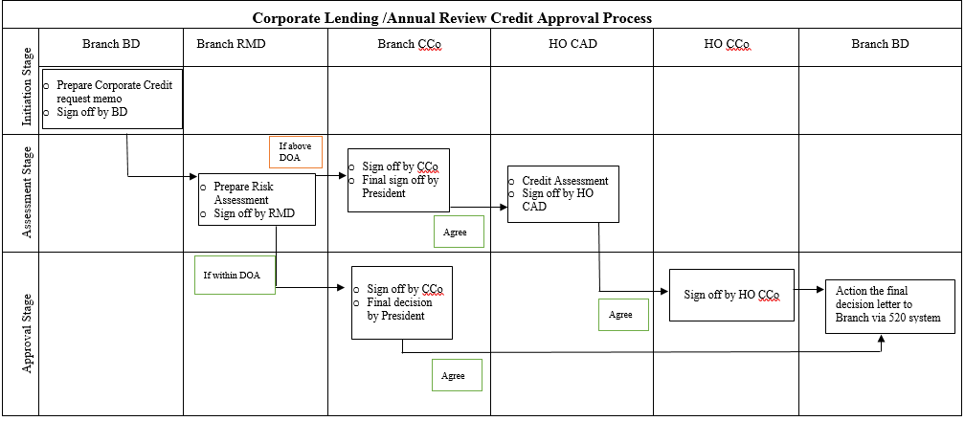

Business Development Department (“BD”) London Branch propose the limits to Risk Management Department (“RMD”), the request should specify:

* Business Group (Parent/Ultimate owner)
* Legal Entity
* Country of Risk
* Type of Request
* Request Deadline
* Purpose and rational of request
* Client Background
* Key Terms: Products, Currencies, Loan Amounts, Tenors, Interest Rate, Repayment Schedules, Covenants etc.
* Key Risks and Mitigants
* Recommends
* Support docs

RMD takes the following responsibilities:

* Credit analysis
* Internal Credit Rating mapping to HO Internal Credit Ratings
* Assess maximum credit limits under local delegated authority
* Assess currencies, products and tenors requested
* Presents to the Branch CCo

The Branch CCo:

* Challenge limit requests (consider Credit Risk Appetite requirements)
* Approve limits for the Branch
* If above the local delegation level, Branch CCo agree limits to be sent to HO (“Head Office”) Credit Approval Department (“CAD”)

Head Office CAD:

* Consider Branch limits request
* If the limit approved by HO, CAD should grant the formal approval letter to the Branch via 520 system.

RMD London Branch

* Monitor limits and exposure on daily basis
* Report risk profile to Branch CCo/ManCo (Monthly)
* Report risk profile to HO (Quarterly)

All above limits are reviewed on annual basis using the same credit approval procedure as a new request.

# Appendix F – Sovereign/Corporate Bond Credit Approval Process

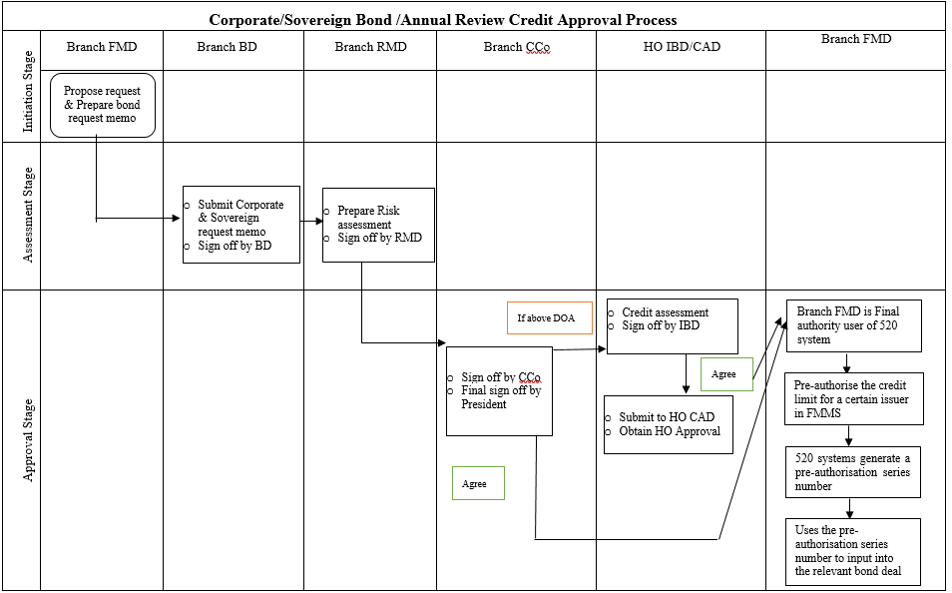

Financial Market Department (“FMD”) London Branch propose the limits to BD via email, the request should specify:

* Counterparty Name
* Corporate Bond or Sovereign Bond Details: Amounts, Currencies, Tenors, Interest Rate
* Country of Risk
* Purpose and rational of request

BD London Branch propose the requests to RMD London Branch, the request should:

* Short term request memo (please see the format in appendix C)
* Provide the consolidated Corporate or Sovereign limit and exposure

RMD takes the following responsibilities:

* Short form credit analysis (please see the format in appendix C)
* Mapping External Credit Assessment Institution (“ECAI”)’s to HO internal credit rating
* Assess maximum credit limits under local delegated authority
* Assess currencies, products and tenors requested
* Presents to the Branch CCo

The Branch CCo:

* Challenge limit requests (consider Credit Risk Appetite requirements)
* Approve limits for the Branch
* If within Local delegation authority,

-the final approval will be issued through 520 system;

-London FMD pre-occupy the credit limit for a certain issuer in FMMS;

-520 systems generate a pre-occupied series number;

-London FMD trader uses the pre-occupy series number to input into the relevant bond deal in FMMS;

-Finally, Trader can activate the transaction and take up the credit limit.

* If above the local delegation level, Branch CCo agree limits to be sent to HO IBD

Head Office IBD:

* Consider Branch limits request
* HO grant the formal approval letter to the Branch *via* 520 system and the Branch is the final authority user of 520 system
* London FMD pre-occupy the credit limit for a certain issuer in FMMS;
* 520 systems generate a pre-occupied series number;
* London FMD trader uses the pre-occupy series number to input into the relevant bond deal in FMMS;
* Finally, Trader can activate the transaction and take up the credit limit.

RMD London Branch (Middle Office)

* Monitor limits and exposure on daily basis
* Report risk profile to Branch CCo/ManCo
* Report risk profile to HO (Quarterly)

All above limits are reviewed on annual basis, and same credit approval procedure as new request.

# Appendix G –Financial Institutions Credit Approval Process

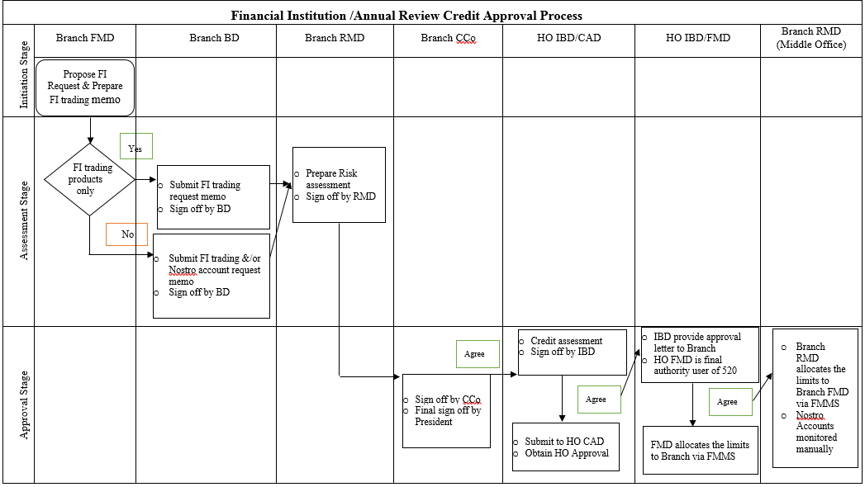

FMD London Branch propose the limits to BD off-line (email or memo) the request should specify:

* Counterparty Name
* Country of Risk
* Legal entities to trade with including all Branches/Subsidiaries
* Products
* Currencies
* Tenors
* Purpose and rational of request

BD London Branch propose the requests to RMD London Branch (off-line), the request should:

* Propose the combined FI limits including FMD request and Nostro accounts
* Credit request memo

RMD takes the following responsibilities:

* Credit analysis
* Mapping ECAI’s to HO internal credit rating
* Assess maximum credit limits under local delegated authority
* Assess currencies, products and tenors requested
* Presents to the Branch CCo

The Branch CCo:

* Challenge limit requests (consider Credit Risk Appetite requirements)
* Approve limits for the Branch
* Agree limits to be sent to HO IBD

Head Office IBD:

* Consider Branch limits request
* If the limit approved by HO, IBD will provide the formal approval letter to the Branch
* If FI trading limit (including FI bond) approved, HO FMD allocates the limits to Branch via FMMS system (HO reserves the right to monitor and re-allocate the limits, if not utilised).
* If Nostro account limit approved, IBD allocate the limits to Branch offline.

RMD London Branch (Middle Office)

* Allocate the HO FMD limits to FMD London Branch in FMMS system (Products)
* Monitor limits and exposure on daily basis
* Report risk profile to Branch CCo/ManCo (Monthly)
* Report risk profile to HO (Quarterly)

All above limits are reviewed on annual basis, and same credit approval procedure as new request.

# Appendix H – Credit Classification

# 

# Appendix I – Credit Rating Methodology

Head Office takes responsibility of developing, updating and maintaining of the corporate internal rating methodology and relevant systems, which provide the rating results for both Chinese and International Corporate Clients and Real Estate Asset-Back Finance.

In line with HO existing policies, there is no internal rating model available for Financial Institutions, Sovereign and Project Finance.

***Corporate Ratings Framework:***

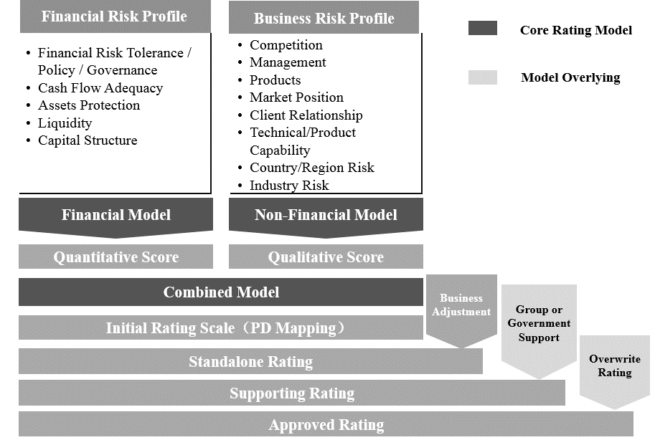

***Models Key Risk Factors:***

|  |  |
| --- | --- |
| **Quantitative Risk Dimension** | **Key Risk Ratios (HO Internal Credit Risk Model)** |
| **Profitability** | Increase rate on ‘Operating Profit’ |
| **Cash Flow** | Increase rate of ‘Net Operating Cash Flow’ |
| **Leverage** | * Total Debt/EBITDA * Total Debt/EBIT * Total Debt/Equity * Net Debt/Equity |
| **Operational Capacity** | * Trade Receivable ratio * Current ratio |
| **Profitability** | Operating Profit Margin, Net Assets Yield, Gross Profit Margin etc. |
| **Growth Rate** | Revenue |
| **Business Scale** | * Total Assets * Net Profit |

|  |  |
| --- | --- |
| **Qualitative Risk Dimension** | **Key Risk Factors (HO Internal Corporate Credit Risk Model)** |
| **Corporate Background** | * Years in operation * Corporate shareholders rating level |
| **Competitiveness** | Industry position |
| **Business environment** | * Changes in share price * Changes in corporate bond yields to LIBOR * Litigation or Regulatory penalties * Corporate governance, operational, environmental, safety events |

|  |  |
| --- | --- |
| **Qualitative Risk Dimension** | **Key Risk Factors (HO Internal Real Estate Credit Risk Model)** |
| **Country Risk** | * Location * City * Distance from City center |
| **Business environment** | * Type of business * Price reduction headroom * Prices in surrounding area * Project progress (if development) |



***Probably of default mapping***

|  |  |  |  |
| --- | --- | --- | --- |
| HO Internal Rating | Upper Limit | Lower Limit | PD |
| AAA+ | 0.00% | 0.06% | 0.05% |
| AAA | 0.06% | 0.15% | 0.11% |
| AA+ | 0.15% | 0.27% | 0.21% |
| AA | 0.27% | 0.50% | 0.39% |
| A+ | 0.50% | 0.88% | 0.68% |
| A | 0.88% | 1.35% | 1.10% |
| BBB+ | 1.35% | 1.90% | 1.61% |
| BBB | 1.90% | 2.66% | 2.24% |
| BB+ | 2.66% | 3.70% | 3.10% |
| BB | 3.70% | 5.00% | 4.25% |
| B | 5.00% | 6.40% | 5.58% |
| CCC | 6.40% | 8.00% | 7.09% |
| CC | 8.00% | 10.00% | 8.86% |
| C | 10.00% | 25.00% | 17.24% |
| C- | 25.00% | 100.00% | 31% |
| D | 100.00% | 100.00% | 100.00% |

# Appendix J – Risk Weighted Asset (RWA) calculation

Head Office takes responsibility of developing, updating and maintaining of the RWA methodology and relevant systems, which provides the risk weighted exposure for HO capital reporting.

In line with HO existing policies, CNCBLB will calculate RWA to measure and monitor exposures against RAS limits. The HO model had been developed using the following BASEL formula:

RWA = EAD x K x 12.5

Where K is:

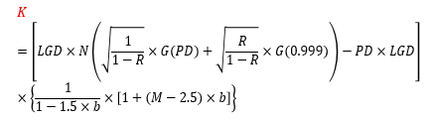

* 1. The RWA excel model provided by HO requires the following inputs:**EAD (**Exposure at Default), the net exposure to the obligor, counterparty or issuer.
  2. **PD** (Probability of Default), determined by the mapping of the ‘Internal Credit Rating’ to the HO approved PD matrix.
  3. **LGD** (Loss Given Default), unsecured loans default to 45%. Security/Collateral must be taken into account in order to reduce the LGD (EG: Cash cover is 0%, Commercial Mortgages are 35%).



# Appendix K – Risk Adjusted Return on Capital (RAROC) calculation

Head Office takes responsibility of developing, updating and maintaining of the RAROC methodology and relevant systems, which provides the risk adjust return on capital that Business Development and the Credit Committee use to determine if a deal/transaction is feasible for the Branch.

In line with HO existing policies, CNCBLB input the following data into the model:

|  |  |
| --- | --- |
| Income | Deal/Transaction |
| Estimated exposure/ approval | Tenor |
| Interest rate expected (eg: Libor +1.5%) | Repricing cycle |
| Fee Income expected (eg: 50bps) | Credit Rating |
| Expected costs FTP (Libor + Margin) | Industry |
|  | Currency |
|  | Guarantee method |
|  | Guarantor Credit Rating/Industry |
|  | Mitigation (Collateral) |

The RAROC model then calculates the risk adjusted return.



ECL / Provision should be included but has no impact on the RAROC calculation.

# Appendix L – HO IFRS9 calculation methodology

Head Office has developed IFRS9 calculation methodology for the Branch requirements in order to measure and report ‘Expected Credit Loss’.

Expected Credit Loss (“ECL”) =Probability of Default (“PD”) * Loss Given Default (“LGD”)* Exposure at Default (“EAD”)

| **Stages** | **Formula** |
| --- | --- |
| Stage 1 | ECL= ${PD}_{1}×{LGD}_{1}×{EAD}_{1}$ |
| Stage 2 | $ECL=\sum_{i=1}^{N}{（{PD}_{i}×{LGD}_{i}×{EAD}_{i}}×\frac{1}{{( 1+EIR )}^{i-1}}$） |
| Stage 3 | ${ECL=LGD}_{1}×{EAD}_{1}$ or Impairment calculation on individual asset basis |

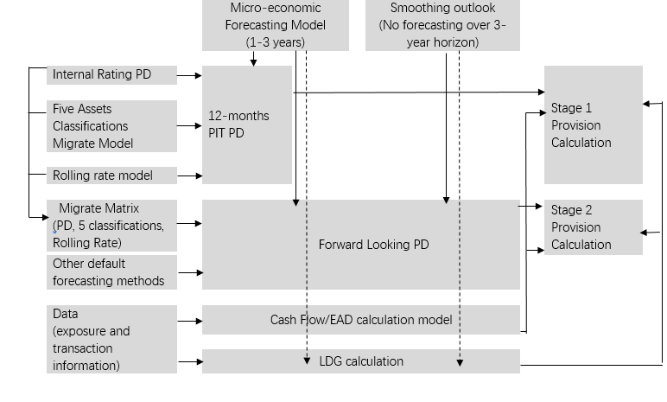***IFRS9 Calculation Framework***

***Definitions and Methodologies***

|  | **Stage 1** | **Stage 2** | **Stage 3** |
| --- | --- | --- | --- |
| Stage Allocation  Criteria | Meet all criteria if applicable:  No sign of credit deterioration  (IFRS 9.5.5)   * ≥30 days past due (capital or interest) * Asset classification ‘Normal’ * PD ≠1 * No advanced payment | Any exposure that is not included in either Stage 1 and Stages 3  Credit quality deterioration can be observed (IFRS 9.5.5.3) | Clear sign of impairment or credit event   * ≥90 days past due (capital or interest) * Asset classification ‘Non-performing loan’, Substandard, Doubtful and/or Loss * PD=1 |
| PD | **Through the cycle PD**  *(“PD TTC”)*   * Assesses the obligor’s average credit-worthiness * Translates the financial data into a PD TTC rating * PDTTC does not reflect economic cycle impact * Calculate PD **TTC** from internal rating or external rating   **Point-in-time PD**  *(“PD PIT”)*   * Assesses the probability of default over the next 12 months; * Converting from PD TTC to PD PIT through forward looking adjustments to reflect the current point of micro-economic impact on the obligor’s creditworthiness; * Correlations conversion defined in HO methodology (on file): | **Forward-looking PD**  HO Model conducts a regression analysis covering:   * Multiple UK historical micro-economic data points and historical UK commercial bank non-performing loan ratio; * Micro-economic scenarios forecasting to calculate a forward-looking PD; * Historical UK micro-economic factors: i.e. GBP, unemployment rate, CPI. * Only conducts the forward-looking adjustments for the two years and the remaining years without adjustments. | **PD=100%** |
| LGD | 1. **Corporate loan and bond exposures:**  * Unsecured LGD default rate:   + senior debt 45%   + junior debt 75% * LGD with collateral: * EAD (net exposure) * Haircut with collateral value * Minimum collateral value level * Default rates range between 35% to 45% depending on the underlying product   ***Please refer to details in the Head Office IFRS9 policy – on file with Risk Department***   1. **Financial Institution LGD:15%** | | |
| EAD | **Key factors:**   1. the principal cash-flow payment at time 2. interest cash-flow payment at time 3. off balance sheet Credit Conversion Factors (“CCF”)  |  |  | | --- | --- | | **Off B/S Assets Type** | **CCF** | | **Acceptance Bill** | 100% | | **Letter of Guarantee** |  | | Financing Guarantee | 100% | | Non-financing Guarantee | 50% | | **Loan commitment** |  | | Unconditional and revocable to cancel at any time | 0% | | Not unconditional and revocable and cannot be cancel at any time | 75% | | **Letter of Credit** |  | | Documentary credits within one year | 20% | | Documentary credits more than one year | 100% |   **Principle Formula:**   1. Balance/Sheet EAD = outstanding balance+ accrued interest 2. Off Balance/Sheet EAD=Capital * CCF   ***Note: the detailed formula for different stages, please refer to Head Office IFRS9 policy for overseas branch*** | | |